AI or Not?

AI or Not?

Activity Overview
Students learn to identify AI systems in their world by sorting examples, discovering key features, and building a common definition of artificial intelligence.
Learning Objective  Students identify key characteristics of AI systems and recognize AI in everyday life. | Standards & Competencies  - 1a (Recognize AI Systems)  - 1b (Understand Mechanics)  - CCSS.ELA-LITERACY.SL.4.1 (Engage in collaborative discussions)
Materials  - Technology cards (Set 1 and 2) | Preparation  - Prepare technology example cards for student groups.

Launch (1 minute)
Slide | Exploration Guide
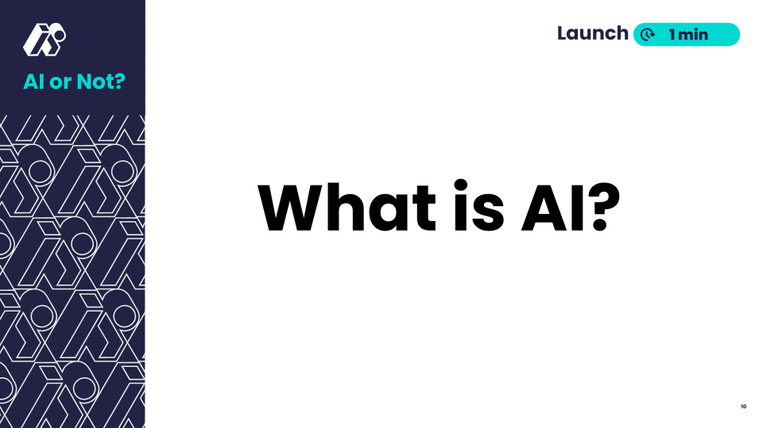 | Say: “What is AI? What are some examples of AI in your daily life?”  Say: “Today we’ll explore what makes something 'AI' by sorting examples and creating our own definition.”  Look For:  - Students sharing examples of AI they’ve encountered  - Students sharing initial criteria for AI  Common Student Misconceptions:  - Misconception: All technology is AI.  - Response: Technology is AI only if it can learn and change its behavior. Many technologies follow fixed rules without learning.
💡Teaching Tip: Collect and display key student language used to describe technology.

Play (12-16 minutes)
Slide | Exploration Guide
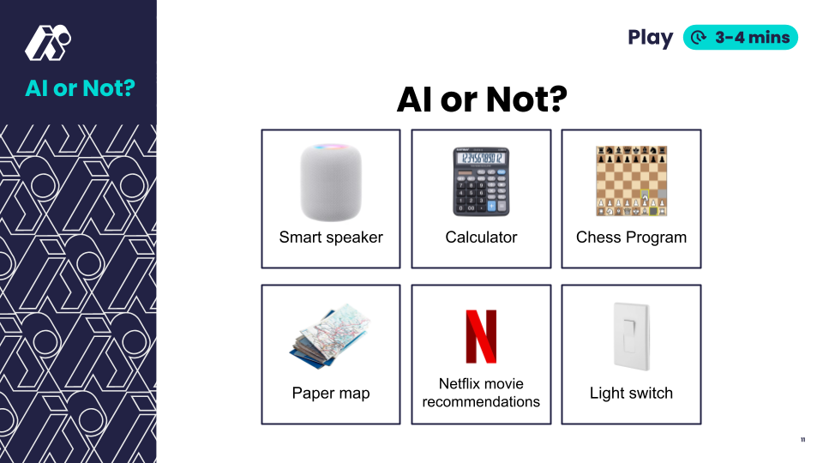 | Distribute technology cards set 1.  Say: "Sort these technologies into two groups: AI and Not AI. Be ready to explain your thinking."  In pairs, students sort cards into “AI” or “Not AI” groups and explain their reasoning.  Look For:  - AI: smart speaker, chess program, Netflix recommender  - Not AI: calculator, paper map, light switch  - AI learns and improves from data and feedback  Common Student Misconceptions:  - Misconception: All technology is AI.  - Response: Technology is AI only if it can learn and change its behavior. Many technologies follow fixed rules without learning.
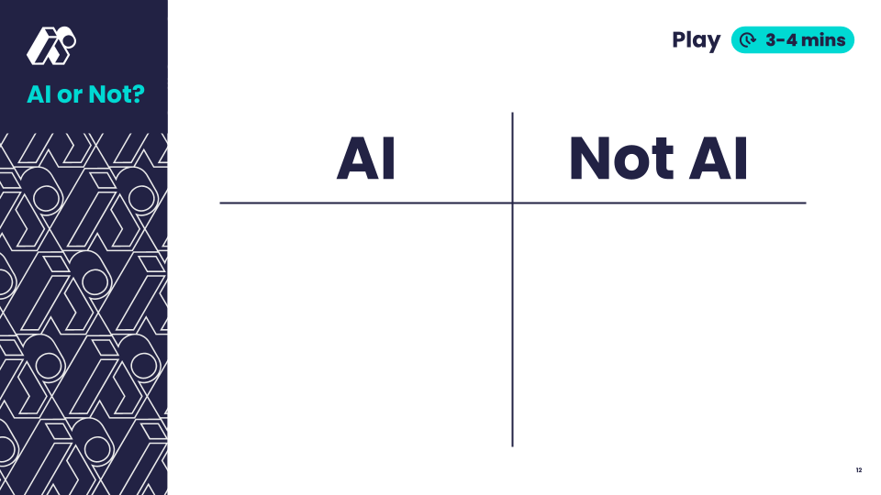 | Say: "What do AI technologies have in common? How are they different from non-AI technologies?”  Record student ideas, guide discussion toward AI’s capacity to learn and adapt to data and feedback  Look For:  - AI can learn from data, change behavior and improve over time.  - Non-AI have fixed rules and fixed behaviors. They cannot learn and change themselves over time.
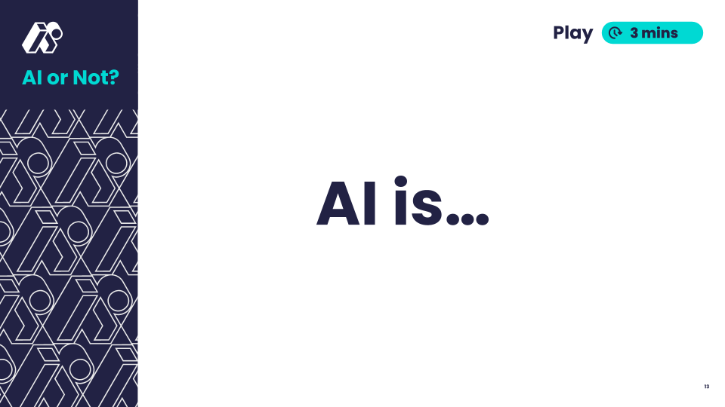 | Say: "Using these features, let's create our own definition of AI."  Students draft a definition in small groups  Share whole group and combine.  Look For:  - AI can learn from data, change behavior and improve over time.  Key Vocabulary:  - Artificial intelligence - technology that learns from information and finds patterns to solve problems
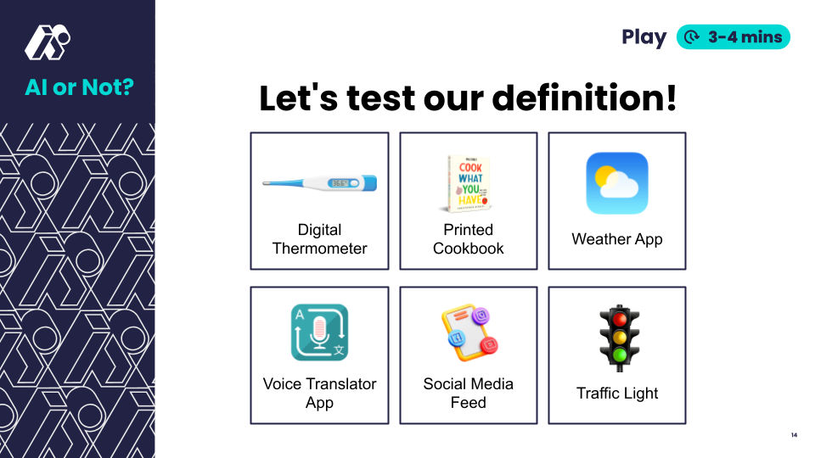 | Distribute technology cards set 2.  Say: "Let's test our definition. Does it help us identify which examples are AI?"  In pairs, students apply shared definition to sort cards into “AI” or “Not AI” groups.  Look For:  - Students thinking critically about each example using the shared AI definition  - AI: translation app, weather app, social media feed  - Not AI: traffic light, cookbook, thermometer
💡Teaching Tip: Provide students with T-charts to organize their thinking. Create and display a class chart to record student ideas.

Land (2 minutes)
Slide | Exploration Guide
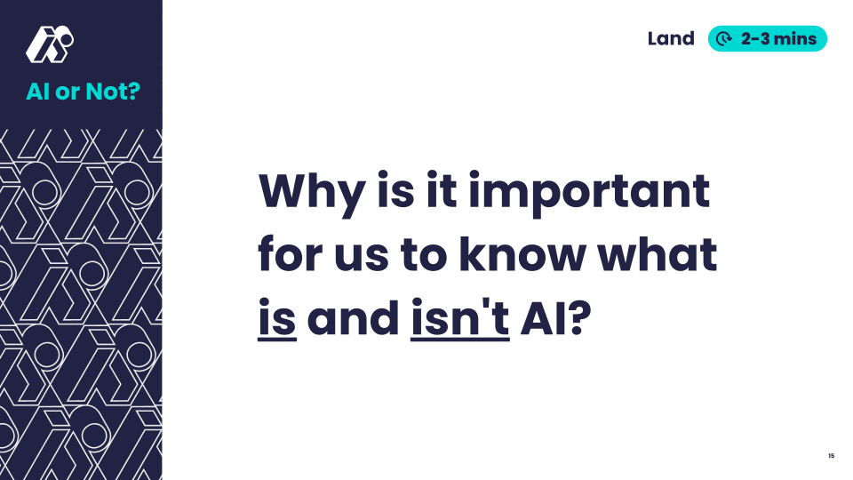 | Students think independently for 1 minute, then share with a partner and/or whole group.  Guide discussion to have students draw critical connections to daily life  Look For:  - AI affects our daily choices  - AI influences what we see/hear/choose  - Understanding AI helps us use it wisely
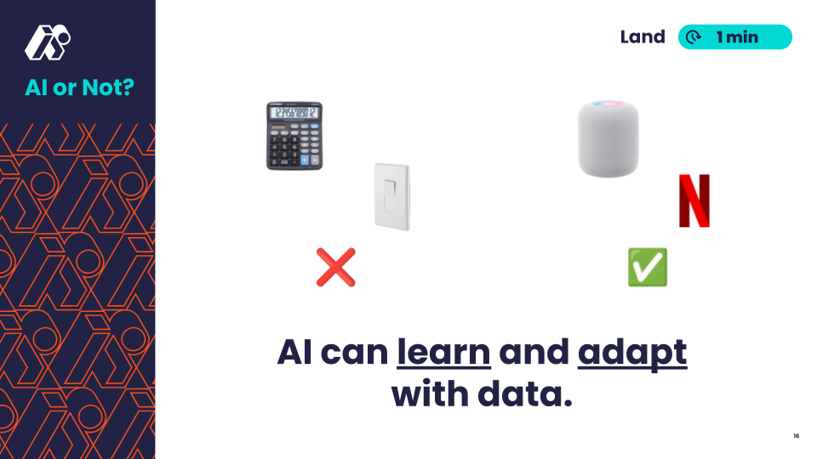 | Say: “AI systems learn and improve over time. Regular technology follows fixed rules.”
💡 Teaching Tip: Allow students options to share their responses, including verbally, by writing a sentence, or by drawing a scene showing why AI awareness matters.

